^{HTML}
- In HTML, "SPA" stands for Single Page Application, and "MPA" stands for Multi-Page Application.
- Single Page Application (SPA):
  - In a SPA, the entire application is contained within a single HTML page.
  - Navigation and content updates are handled dynamically through JavaScript, typically using frameworks like React, Angular, or Vue.js.
  - SPAs provide a smoother user experience as only the content that needs to change is fetched from the server, and the page doesn't need to reload entirely.

- Multi-Page Application (MPA):
  - In an MPA, each page of the application is served as a separate HTML document.
  - Navigation typically involves full page reloads when moving between different sections or pages of the application.
  - MPAs are simpler to build and maintain for smaller projects but may provide a less seamless user experience compared to SPAs.

- The <!DOCTYPE> declaration in HTML (short for Document Type Declaration) is an instruction to the web browser about what version of HTML the page is written in.

- It's not an HTML tag; instead, it's an instruction that precedes the HTML code and tells the browser how to interpret the document.

- For HTML5, the doctype declaration is simply: <!DOCTYPE html>.

- Semantic HTML tags are elements that carry meaning about the content they contain, providing context to both the browser and developers.

- <header>: Represents introductory content, usually at the beginning of a section or page. It often contains logos, navigation menus, or introductory headings.
- <nav>: Defines a section of navigation links.
- <main>: Specifies the main content of the document. It should not contain content that is repeated across multiple pages (such as navigation or footer).
- <article>: Represents a standalone piece of content, such as a blog post, news article, or comment.
- <section>: Defines a section in a document, typically with a heading. It's a generic container for thematic grouping of content.
- <aside>: Contains content that is tangentially related to the content around it, such as sidebars or pull quotes.
- <footer>: Defines a footer for a document or section. It usually contains metadata, copyright information, or links to related documents.
- <figure>: Represents self-contained content, such as images, diagrams, illustrations, code snippets, etc. It's often used in conjunction with <figcaption> to provide a caption.
- <figcaption>: Represents a caption or legend for a <figure> element.
- <time>: Specifies a specific time or range of time, typically used to represent dates, times, or durations.
- <mark>: Highlights or annotates a portion of text as being relevant or of special importance.
- <address>: Represents contact information for its nearest <article> or <body> ancestor.
- <details>: Represents a disclosure widget from which the user can obtain additional information or controls.
- <summary>: Defines a visible heading for a <details> element.

HTML5 introduced numerous new features and improvements over its predecessors, offering enhanced capabilities for web developers. Some of the notable new features introduced in HTML5 include:
- Semantic Elements: HTML5 introduced semantic elements like <header>, <footer>, <nav>, <article>, <section>, <aside>, and <main>, which provide clearer structure and meaning to web documents, improving accessibility and SEO.
- Audio and Video Elements: HTML5 introduced <audio> and <video> elements, allowing developers to embed media content directly into web pages without the need for plugins like Flash.
- Canvas: The <canvas> element provides a drawing surface that allows dynamic rendering of graphics, charts, animations, and games using JavaScript.
- SVG: HTML5 includes support for Scalable Vector Graphics (SVG), allowing developers to create vector-based graphics directly within HTML documents, offering better scalability and resolution independence.
- Form Enhancements: HTML5 introduced several new input types (<input type="email">, <input type="url">, <input type="date">, etc.), attributes (such as placeholder, required, autocomplete), and form validation APIs, making form handling more robust and user-friendly.
- Local Storage: HTML5 introduced the localStorage and sessionStorage APIs, allowing web applications to store data locally in the user's browser, enabling persistent client-side storage for offline access and improved performance.
- Web Workers: HTML5 introduced Web Workers, which allow JavaScript code to run in background threads, enabling parallel processing and improving responsiveness in web applications.
- Geolocation: HTML5 provides a Geolocation API that allows web applications to access the user's geographical location, enabling location-based services and personalized content.
- Drag and Drop: HTML5 introduced native support for drag and drop functionality, allowing users to drag elements and drop them onto targets within the web page without the need for third-party libraries.
- Responsive Images: HTML5 introduced the srcset and sizes attributes for <img> elements, allowing developers to provide multiple image sources and specify different image sizes based on device characteristics, such as screen resolution and viewport size.

^{CSS}
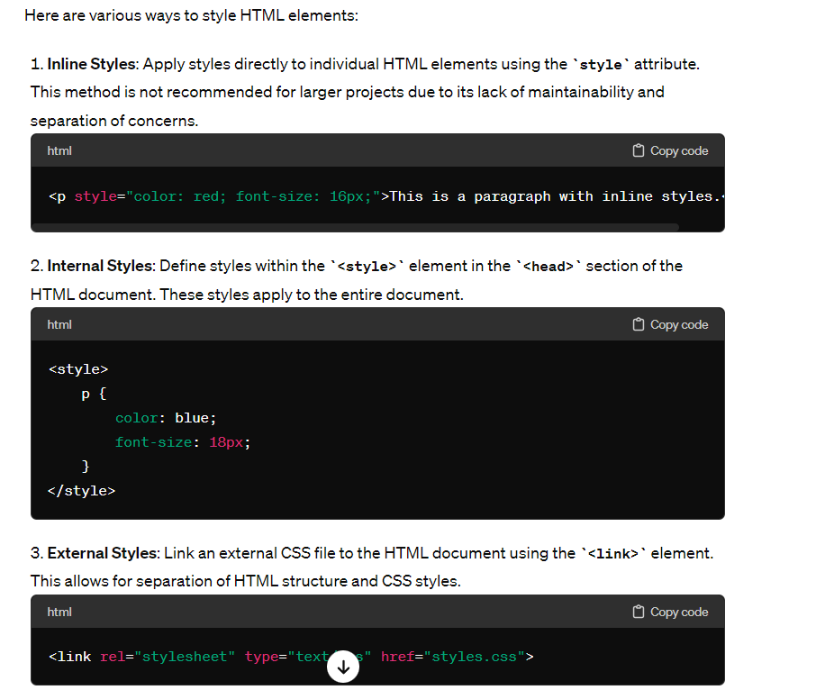
- CSS Preprocessors: Use CSS preprocessors like Sass or Less to write more maintainable and organized CSS code. Preprocessors offer features like variables, nesting, mixins, and functions, which enhance the efficiency of styling.

In CSS, the position property is used to specify the positioning method of an element within its parent container. There are several values that the position property can take:
- static:
  - This is the default value.
  - Elements with position: static; are positioned according to the normal flow of the document.
  - Top, right, bottom, left, and z-index properties have no effect on static elements.
- relative:
  - Elements with position: relative; are positioned relative to their normal position in the document flow.
  - Using top, right, bottom, or left properties will offset the element from its original position.
  - Other elements in the document will not be affected by the relative positioning of the element.
- absolute:
  - Elements with position: absolute; are positioned relative to the nearest positioned ancestor (an ancestor with a position other than static) or to the initial containing block if there is no such ancestor.
  - The element is taken out of the normal document flow, so it won't affect the positioning of other elements.
  - Using top, right, bottom, or left properties will position the element relative to its containing block.
- fixed:
  - Elements with position: fixed; are positioned relative to the viewport, meaning they always stay in the same place even when the page is scrolled.
  - Fixed elements are removed from the normal document flow, so they won't affect the positioning of other elements.
- sticky:
  - Elements with position: sticky; are positioned based on the user's scroll position.
  - A sticky element is treated as relatively positioned until it crosses a specified threshold (usually defined by top, right, bottom, or left properties), at which point it becomes fixed.
In CSS, specificity is a set of rules that determines which styles are applied to an element when multiple conflicting styles are present.
- Inline Styles: Inline styles have the highest specificity. Styles applied directly to an element using the style attribute will always override styles defined in external stylesheets or internal styles.
- ID Selectors: ID selectors have a higher specificity than class selectors and element selectors. They are represented by a hash (#) followed by the ID value.
- Class Selectors, Attribute Selectors, and Pseudo-Classes: Class selectors, attribute selectors, and pseudo-classes have the same specificity. They are less specific than ID selectors but more specific than element selectors.
- Element Selectors and Pseudo-Elements: Element selectors (e.g., div, p, a) and pseudo-elements have the lowest specificity. They are overridden by any other type of selector.

Pseudo-classes in CSS are keywords that specify a special state of an element that can be targeted with CSS selectors.
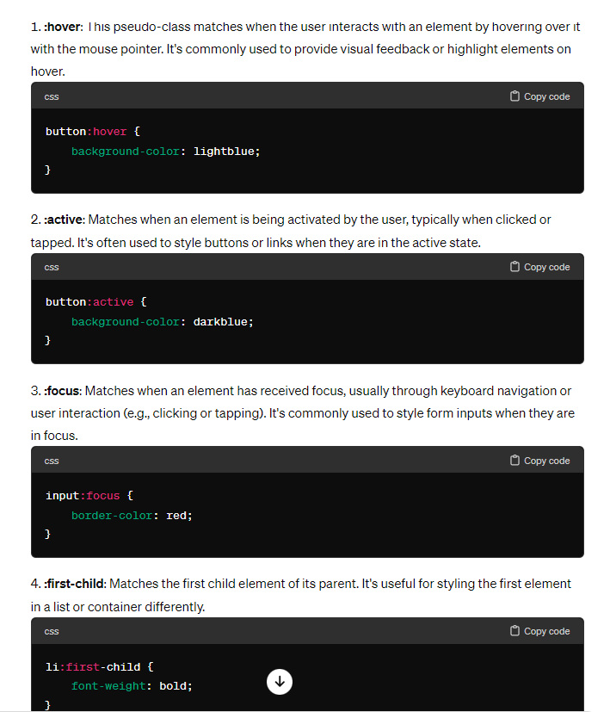
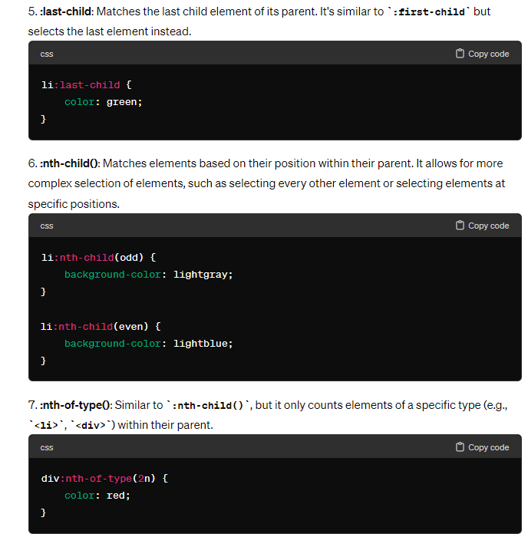
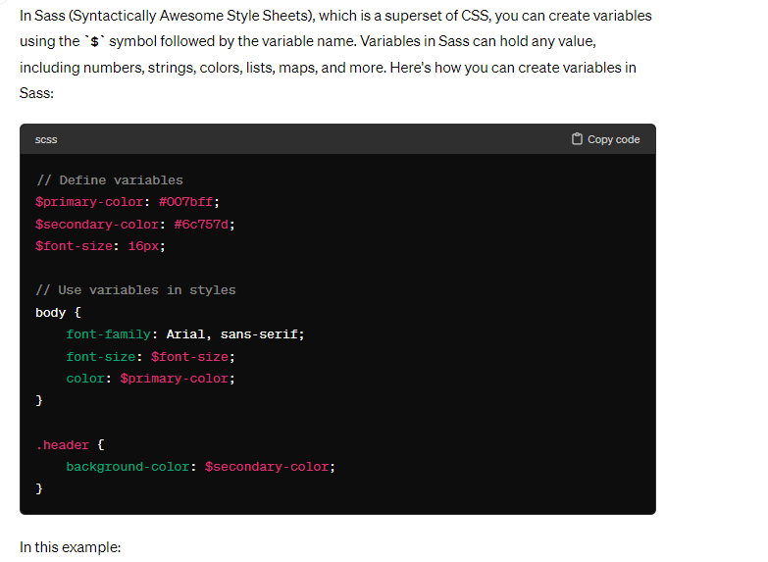
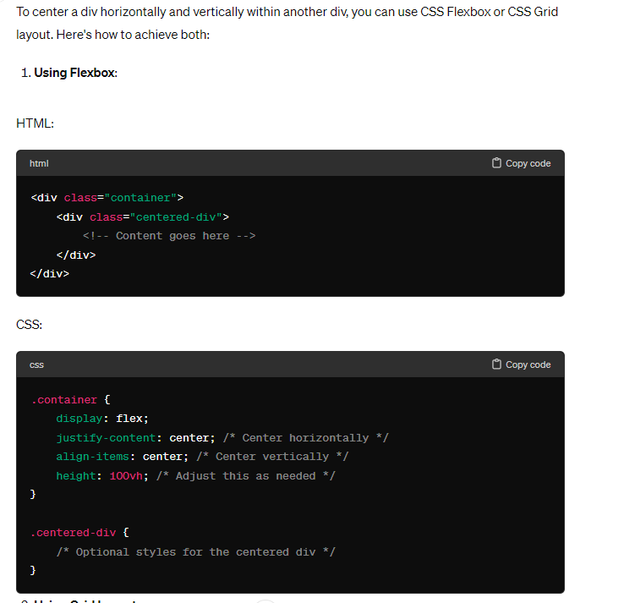
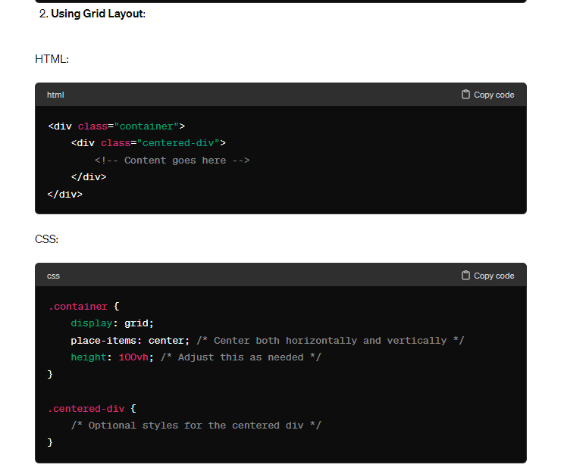

In CSS, -webkit is a vendor prefix used primarily for properties and values that are specific to the WebKit rendering engine, which is used by browsers such as Safari and older versions of Chrome. It allows developers to apply experimental or non-standard CSS features that are only supported by WebKit-based browsers.
For example, -webkit-border-radius was used to apply rounded corners to elements in early versions of Chrome and Safari before the border-radius property was standardized and widely supported across browsers.
However, as browser support for various CSS features has improved and standardized, the need for vendor prefixes like -webkit, -moz (for Mozilla), and -ms (for Microsoft) has decreased significantly. Developers now primarily use them for legacy support or experimental features.

^{JAVASCRIPT}
- In JavaScript, a polyfill refers to a piece of code that provides functionality that is not natively supported by the web browser's JavaScript engine. It essentially "fills in" the gaps in functionality, allowing developers to use newer features of the language or APIs in environments that do not inherently support them.
To load two JavaScript files synchronously, meaning that the second file will only be loaded after the first one has finished loading, you can utilize JavaScript's onload event handler for script tags. Here's how you can achieve this:
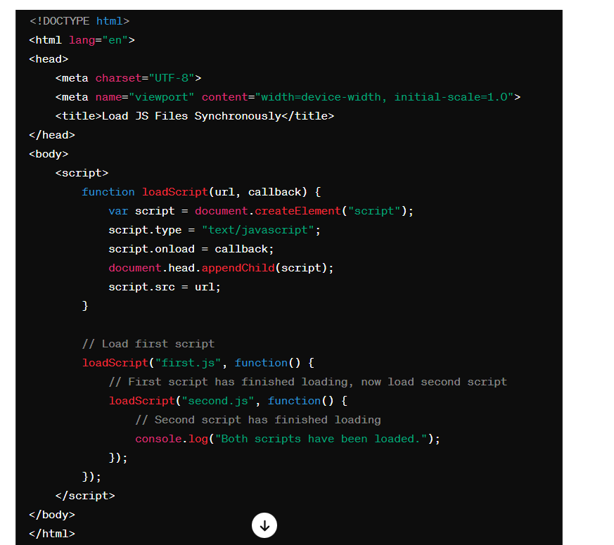

- The async and defer attributes in HTML script tags are used to control how the browser loads and executes external JavaScript files. Both attributes can be added to a <script> tag and affect the order in which scripts are executed in relation to the loading of the HTML document and other resources.
- Async Attribute:
  - When you add the async attribute to a <script> tag, it tells the browser to continue parsing the HTML document while the script is being fetched in the background.
  - Once the script is downloaded, it will pause parsing the HTML document, execute the script, and resume parsing.
  - Multiple scripts with the async attribute can be fetched simultaneously, and they will execute in whichever order they finish downloading.
  - The scripts might not execute in the order they appear in the HTML document, which could lead to potential issues if scripts depend on one another.
- Defer Attribute:
  - When you add the defer attribute to a <script> tag, it tells the browser to continue parsing the HTML document while the script is being fetched, similar to async.
  - However, scripts with the defer attribute will only execute after the HTML document has been fully parsed.
  - Multiple scripts with the defer attribute will execute in the order they appear in the HTML document, after the document has been parsed.
  - Scripts with defer are guaranteed to execute in the order they are specified in the HTML document, which can be useful for ensuring dependencies are met.
- Use async when the script doesn't depend on the DOM or other scripts, and you want it to execute as soon as possible.
- Use defer when the script depends on the DOM or other scripts, and you want it to execute only after the HTML document has been fully parsed.
- If order of execution is crucial and scripts depend on one another, use defer to ensure they execute in the correct order.
- Both async and defer can improve page loading performance by allowing the HTML document to be parsed without blocking for script loading.

The event loop is a fundamental concept in JavaScript that governs how asynchronous operations are executed. It's what allows JavaScript to handle multiple operations efficiently without blocking the execution of other code. Understanding the event loop is crucial for writing performant and responsive JavaScript code.
Here's a high-level overview of how the event loop works:
- Main Thread:
  - JavaScript is single-threaded, meaning it can only execute one piece of code at a time on the main thread.
  - The main thread executes synchronous code in the order it appears in the script.
- Asynchronous Operations:
  - Asynchronous operations, such as setTimeout, XMLHttpRequest, or DOM events, are offloaded to the browser's APIs or the environment's task queue.
  - Asynchronous operations are initiated and scheduled to be executed in the future, but they don't block the main thread while waiting.
- Event Loop:
  - The event loop continuously monitors the main thread's execution stack and the task queue.
  - When the main thread finishes executing synchronous code, it checks if there are any tasks in the task queue.
  - If there are tasks in the queue, the event loop pushes them onto the execution stack one by one, allowing them to be processed.
- Execution Stack:
  - The execution stack (also known as the call stack) is a Last In, First Out (LIFO) data structure that tracks the execution of function calls in JavaScript.
  - Synchronous function calls are added to the stack when they are executed and removed when they are completed.
- Task Queue:
  - The task queue (also known as the callback queue) holds tasks that are scheduled to be executed asynchronously.
  - When an asynchronous operation completes, its callback function is added to the task queue.
- Microtasks Queue:
  - In modern JavaScript environments, there is also a microtask queue that holds tasks with higher priority than regular tasks.
  - Microtasks include promises and certain DOM mutations.
  - Microtasks are processed before regular tasks in the event loop.
Event bubbling and event capturing are two phases of event propagation in the DOM (Document Object Model) that describe how events are handled when they occur on nested elements within a document. These concepts are essential to understand when working with event handling in JavaScript.
- Event Capturing (Capture Phase):
  - During the capture phase, the event propagates from the root of the document down to the target element.
  - In other words, the event is captured by ancestors of the target element, starting from the outermost ancestor and moving inward toward the target.
  - Event handlers registered with the capture phase are executed during this phase.
  - Event capturing is less commonly used in practice but can be useful for intercepting events before they reach their target.
- Event Bubbling (Bubbling Phase):
  - After the capture phase completes, the event enters the bubbling phase.
  - During the bubbling phase, the event propagates from the target element up through its ancestors to the root of the document.
  - This propagation resembles bubbles rising up from the target to the top of the document tree.
  - Event handlers registered with the bubbling phase are executed during this phase.
  - Event bubbling is the default behavior in most cases and is widely used in event handling.

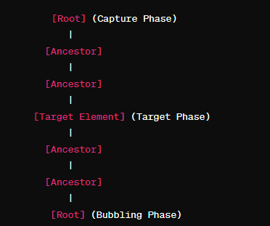
In JavaScript, you can specify whether to use event capturing or event bubbling when registering event handlers using the addEventListener() method. The third parameter of addEventListener() allows you to specify whether the event should be captured (true) or bubbled (false, default behavior).
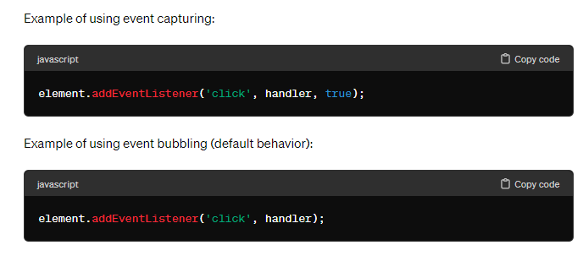
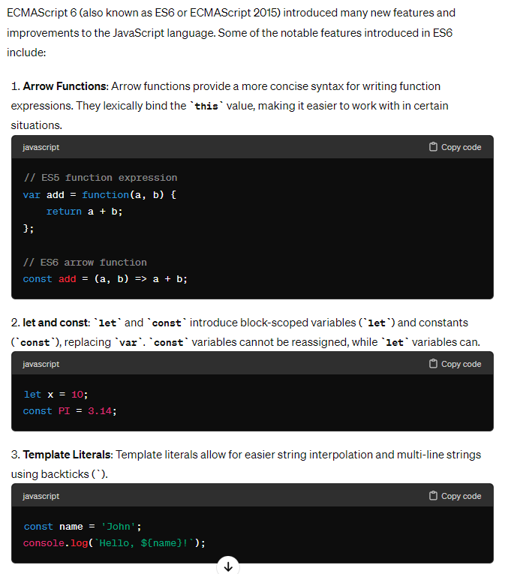
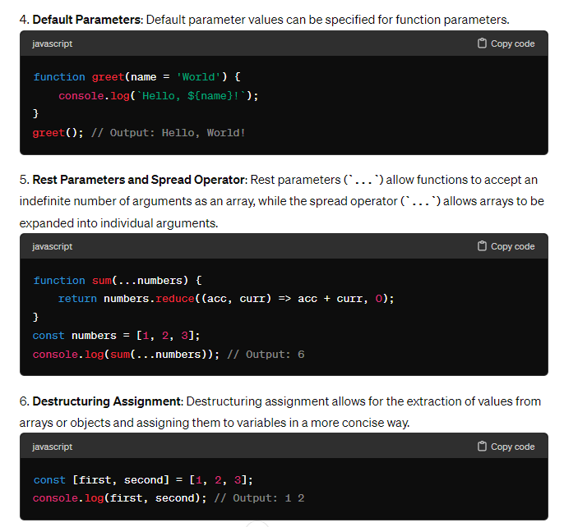
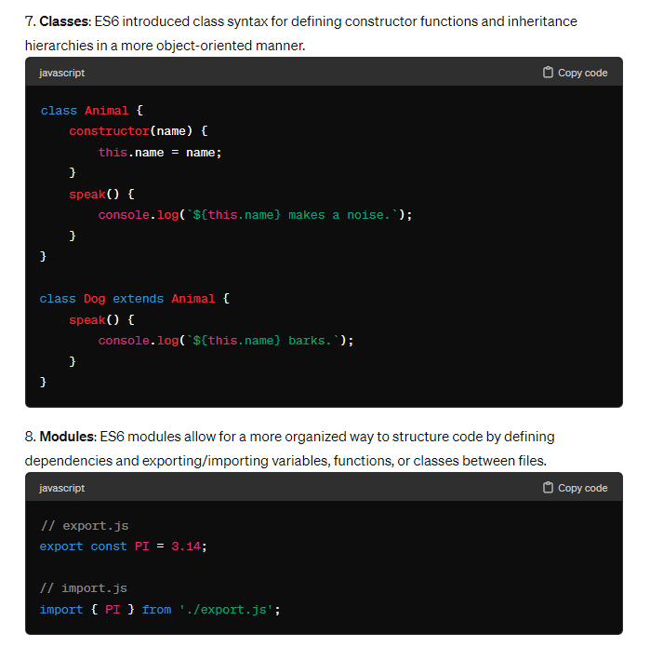

Methods to create object
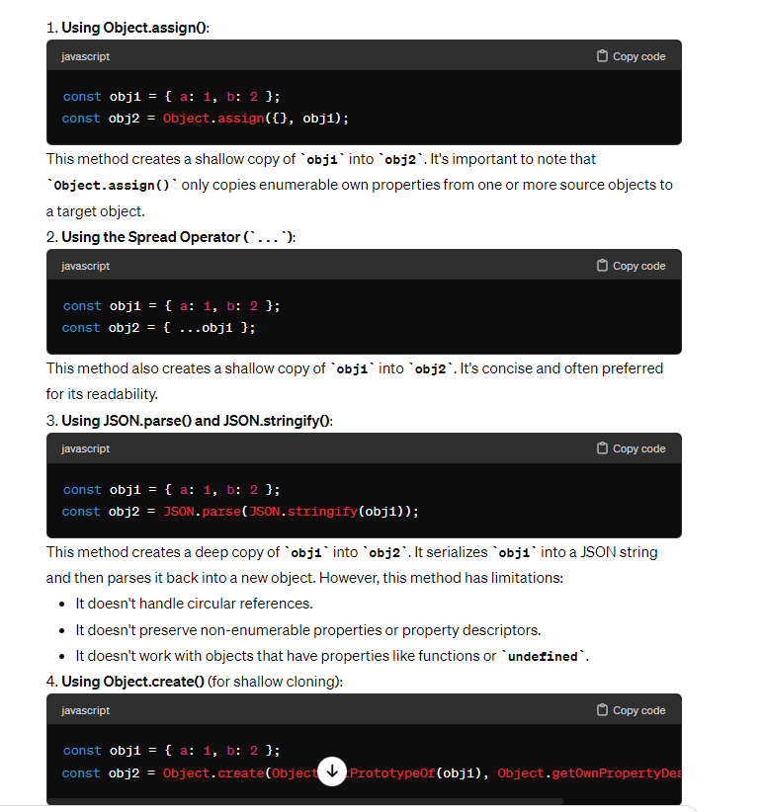
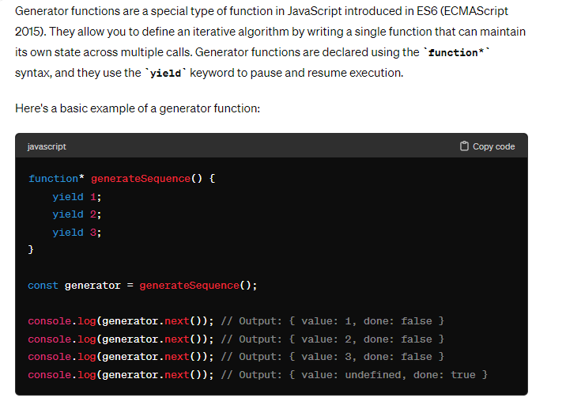
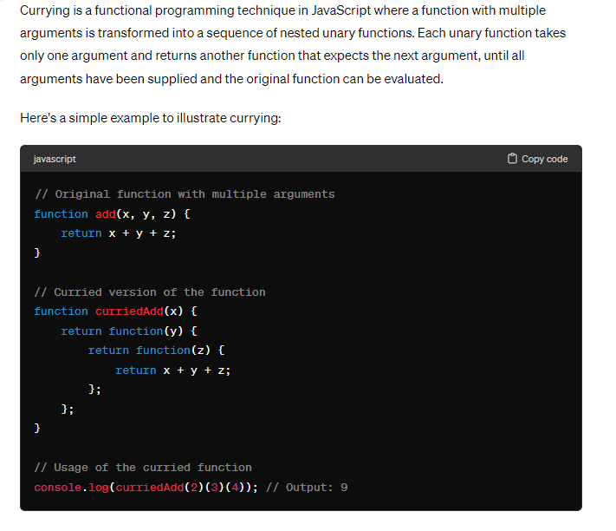
- In js, when we try to merge arrays using + operator, it will not work because it converts to string and merge it, so use concat()
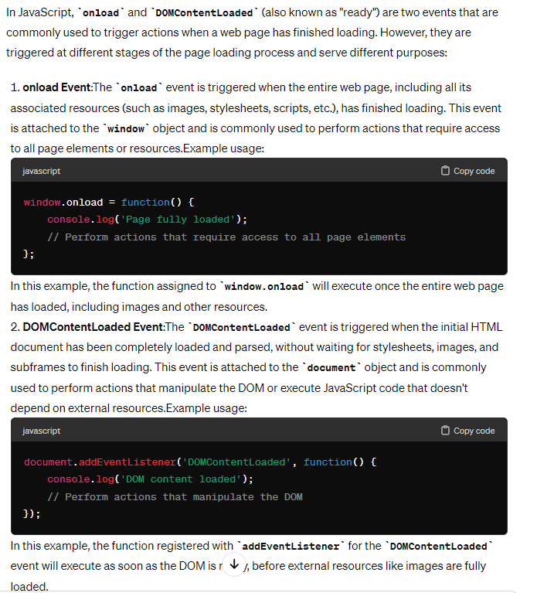

Call, apply , bind
- These are used to bind objects to this keyword
- call takes arguments whereas in apply it takes array of arguments.

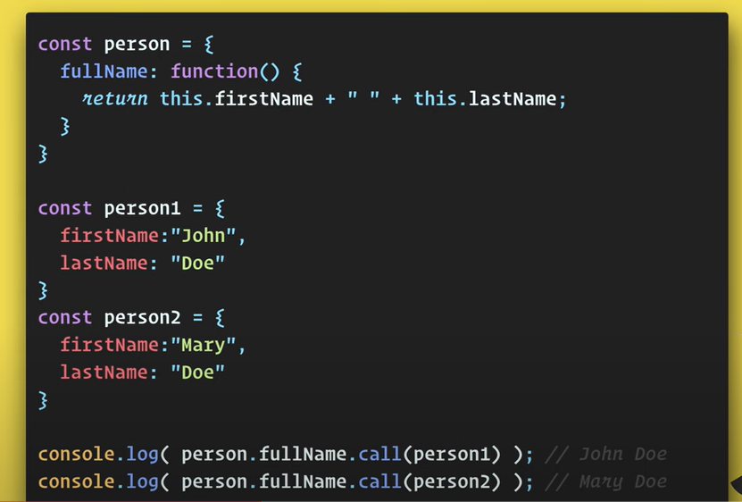

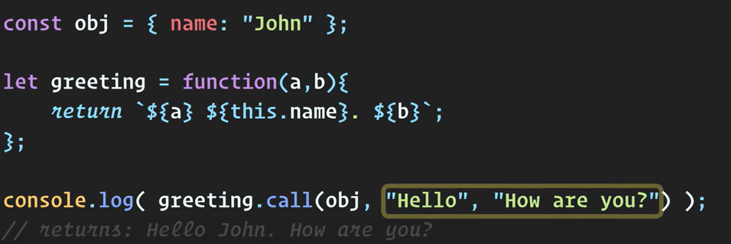

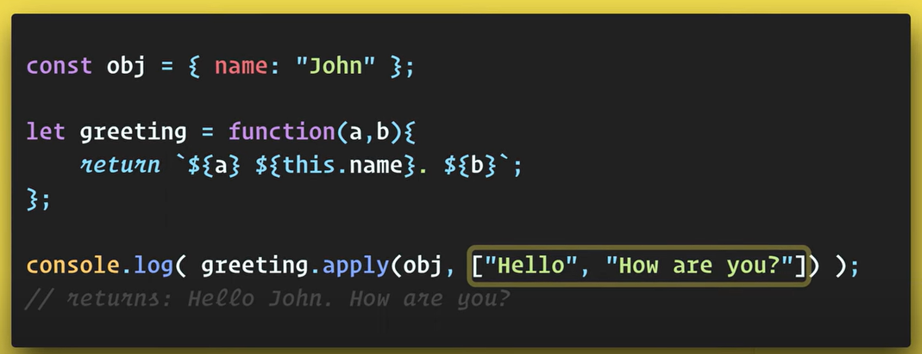

To find max number in an array in js using apply
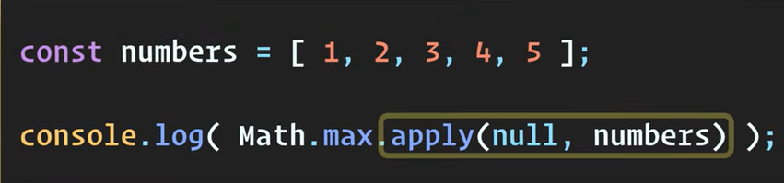
- Bind creates a bound function
